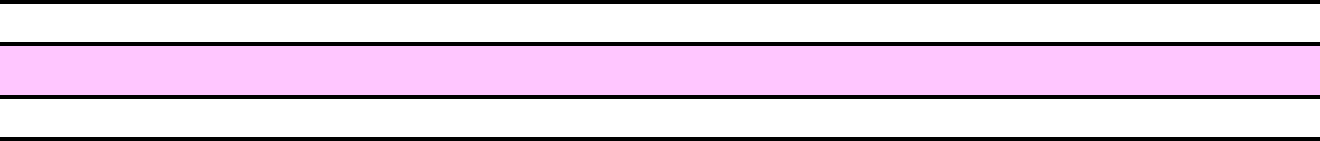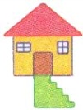 S S S S S S S S S S S

 S S S S S S S S S S S

 S S S S S S S S S S S

 S S S S S S S S S S S

 S S S S S S S S S S S

 S S S S S S S S S S S

 S S S S S S S S S S S