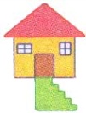 C C C C C C C C C

 C C C C C C C C C

 C C C C C C C C C

 C C C C C C C C C

 C C C C C C C C C

 C C C C C C C C C

 C C C C C C C C C